RAILWAY MANAGEMENT SYSTEM
Main Menu – Show available trains
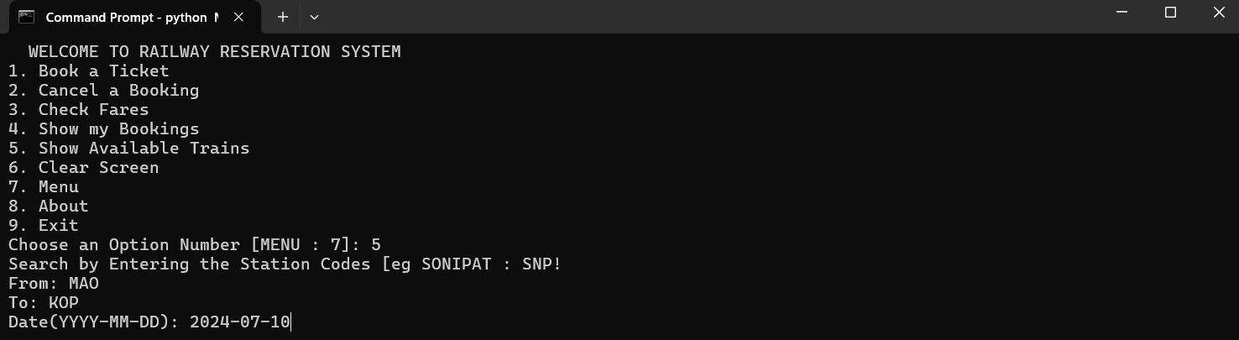
Book a Ticket
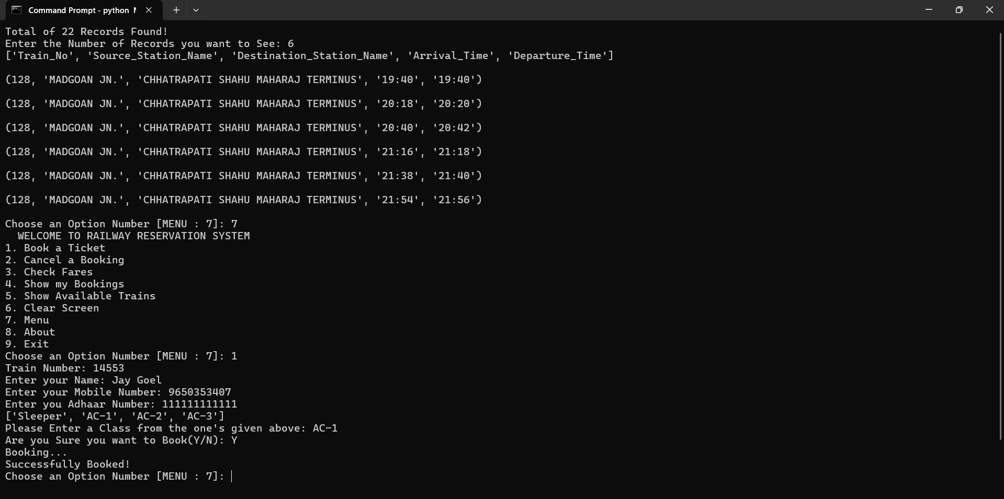
Check Fares of Train
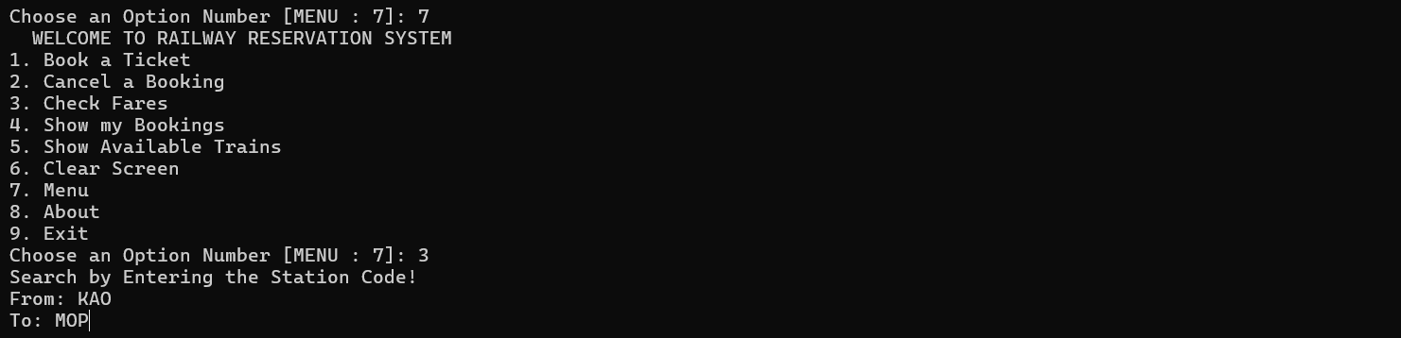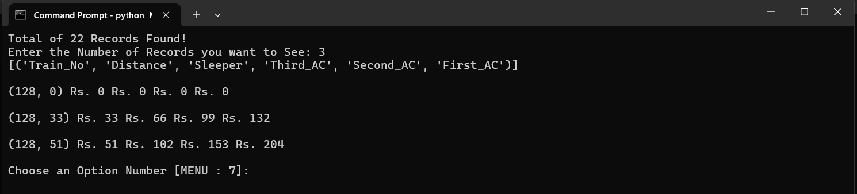
Show My Bookings
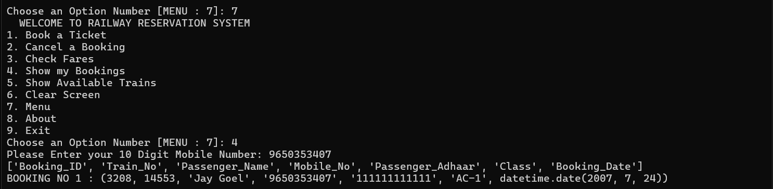
Cancel My Booking
